Source: http://www.craigbadura.com/2013/02/the-digital-citizenship-survival-kit.html?m=1

Padlock
The padlock is to remind students to set strong passwords and to set up passcode locks on all of their digital devices. "Lock 'emdown" as we like to say in our Digital Citizenship lessons.

Toothbrush
I tell students to think that passwords and toothbrushes are very similar in the fact that you NEVER want to share passwords. (I do highly encourage/recommend that students to share passwords with parents)

Permanent Marker
Everything that you put online is permanent....even if you hit the delete button after posting. Odds are someone has retweeted, favorited, or taken a screenshot of the material if it was questionable.

Toothpaste
Imagine the information that you are putting online is like the toothpaste coming out of the tube. Once it is out, it is almost impossible to get it all back in the tube! (Thanks to @Mandery for that prop idea!)

Soap
Keep it clean!

Picture of Grandma
don't post anything you wouldn't be happy for her to see

I LOVE this idea! The use of props the my 8th graders can relate to is great! The soap is an awesome addition. My idea is to add a small measure tape with a quote from the English historian Thomas Babington Macaulay (1800-1859). "The measure of a man's real character is what he would do if he know he would never be found out." Then I would add, "Make sure your character measures up...online and off!!"

Name: _____________________________ Period: _______ Date: _________________
Digital Citizenship Survival Kit

PADLOCK
_____________________________________________ _____________________________________________
TOOTHBRUSH
__________________________________________________________________________________________
PERMANENT MARKER
__________________________________________________________________________________________
TOOTHPASTE
__________________________________________________________________________________________
PHOTO OF GRANDMA
__________________________________________________________________________________________
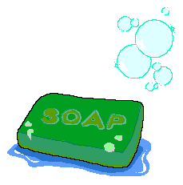
BAR OF SOAP
__________________________________________________________________________________________

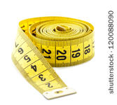
MEASURING TAPE
_____________________________________________
_____________________________________________

- In your own words, what does “digital citizenship” mean? ________________________________________________________________________________________________________________

- Think of 2 more items you could add to the bag. Describe why you chose those items and what they signify/stand for. ________________________________________________________________________________________________________________________________________________________________________________________________________________________________

