Instructional Lesson Plan
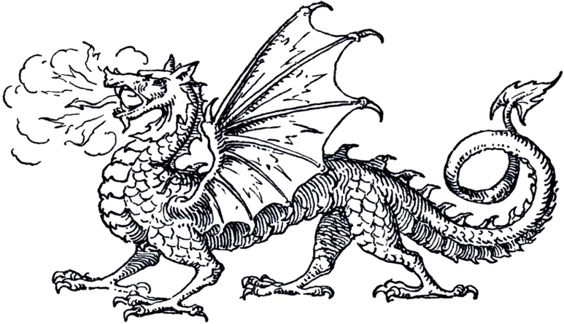
Lesson Plan Overview
Date: September 12-16, 2016
Lesson Title: Focus on Fantasy Book Talk
Lesson Author: Jessica Drinks
Grade Level: 7 and 8
Subject Area: Language Arts
Time Allotted for lesson: one 30-minute class period
Short Description of Lesson
- In this lesson, the students will hear examples of books that belong in the fantasy genre. The books are from different subgenres so that students with differing interests can find fantasy books that they would like to read. A worksheet of book selections will be provided to allow students a reference for future reading choices.
Lesson Plan Standards
- AASL 1.1.2 Use prior and background knowledge as context for new learning.
- AASL 1.1.6 Read, view, and listen for information presented in any format (e.g., textual, visual, media, digital) in order to make inferences and gather meaning
- Language Arts 7.5 The student will read and demonstrate comprehension of a variety of fictional texts, narrative nonfiction, and poetry. a) Describe the elements of narrative structure including setting, character development, plot structure, theme, and conflict. b) Compare and contrast various forms and genres of fictional text.
Instructional Objectives
- Learning outcome: Students will demonstrate an increase in knowledge about the fantasy genre. Students will explain what factors make a book part of the “fantasy” genre.
- Focus
    - Enduring Understandings—Students should come away with a better understanding of the features in books that make it part of the fantasy genre.
  - Essential Questions
    - How do you know that a book belongs in the fantasy genre?
    - What features often appear in books that belong in fantasy?
Procedures
- Lesson Set: The librarian will start the lesson by reading a short passage from a selected book and asking the students to identify which genre the book belongs to based on clues from the reading. The librarian will rotate which book is being read to the class but each book selection will be one of the books from the student handout worksheet so that students can make the connection.
- Rationale: Students have been learning about genre of fictional texts for a couple of weeks now and it encompasses a large part of their standardized test at the end of the school year.
- Techniques and Activities:
  - 1) Read a short passage from a fantasy book and ask students which genre this book would belong to; field answers and answer questions
  - Hand out “Focus on Fantasy” worksheet.
  - Hold up book examples from the worksheet and book talk several of the books so that students can hear a synopsis of the book/series plot. Students were asked to take notes on their worksheets to aid in future book selections as the librarian was talking.
- Lesson Closure
  - Students will be released from the lesson in order to find books for check out. Students were asked to take their Focus on Fantasy worksheet with them and to try out a fantasy book in the next couple of weeks.
Assessment/Evaluation
- The Language Arts teacher is not grading an assignment specifically related to the Fantasy Book Talk, but the teacher is requiring that students read from different genres as part of their required reading assignment.
- Student products: Students are responsible for turning in a required reading log each quarter (9 weeks period) which must include several genres.
- Remediation: Extended learning time will be available for students during Foxes Den time and will be arranged by the Language Arts teacher.
- Adaptations for diverse special learners: Because this is an inclusion class, two collaborative teachers will be available to assist students in addition to the librarian. The special education teacher will work closely with one or two pairs of students to ensure they are actively listening to the book talk.

