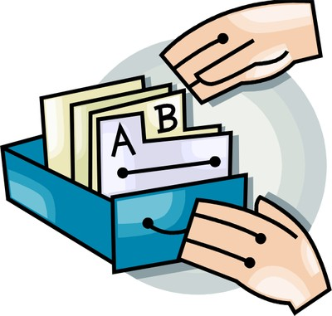
Instructional Lesson Plan
Lesson Plan Overview
Date: Aug. 29-September 2, 2016
Lesson Title: How to use the Destiny catalog
Lesson Author: Jessica Drinks
Grade Level: 7 and 8
Subject Area: Language Arts
Time Allotted for lesson: one 30-minute class period
Short Description of Lesson
- In this lesson, the students will see a demonstration on how to conduct searches within the Destiny online catalog. A short tutorial video will be shown along with a real-time search as a demonstration. Students will complete a short worksheet on the information gained during a catalog search.
Lesson Plan Standards
- AASL 1.1.4 Find, evaluate, and select appropriate sources to answer questions.
- AASL 1.1.6 Read, view, and listen for information presented in any format (e.g., textual, visual, media, digital) in order to make inferences and gather meaning
- Language Arts 7.5 The student will read and demonstrate comprehension of a variety of fictional texts, narrative nonfiction, and poetry. a) Describe the elements of narrative structure including setting, character development, plot structure, theme, and conflict. b) Compare and contrast various forms and genres of fictional text.
Instructional Objectives
- Learning outcome: Students will demonstrate the ability to use the library catalog in order to conduct a basic search.
- Focus
    - Enduring Understandings—Students should come away with a better understanding of the features in a library catalog that allow them to find books by specific searches.
  - Essential Questions
    - How do you find a book on a specific topic?
    - How do you figure out if a book is on your reading level?
Procedures
- Lesson Set: The librarian will start the lesson by showing a short video on how to use 3 basic searches in the Destiny catalog at the school. Many students are unaware of how to find a particular book or a book on a particular topic. Finding relevant information is the basis of any research project they will conduct at school.
- Rationale: Students complete several research projects during the school year, and those projects span several curriculum content areas. Students should be familiar with the online catalog so that they can independently search for books to aid in their research projects.

- Techniques and Activities:
  - 1) The librarian will first show the short video “3 basic searches used in Destiny Catalog” from Daniel Harrington (April 24, 2013) on You Tube: https://www.youtube.com/watch?v=IZAGP_K6QTQ
  - Demonstrate a keyword search, subject search, author search, and title search using the Destiny Follett database projected onto the screen.
  - Hand out the “I can do it myself!” worksheet and have students complete the worksheet at their table.
- Lesson Closure
  - Students will hand in their worksheets when completed and use the remaining class time to check in/ check out books.
Assessment/Evaluation
- The Language Arts teacher will be taking the worksheet as a grade. The librarian will be grading the worksheets for accuracy and completeness and then returning the worksheets to the appropriate teacher.
- Student products: Students will be required to turn in a completed worksheet from the cataloging activity.
- Remediation: Extended learning time will be available for students during Foxes Den time and will be arranged by the Language Arts teacher.
- Adaptations for diverse special learners: Because this is an inclusion class, two collaborative teachers will be available to assist students in addition to the librarian. The special education teacher will work closely with one or two pairs of students to ensure they are actively completing their written assignment.

